**A. (Exact Solutions of One-Factor Plain Options)**

The code defines a unique data type for each option parameter (T, K, sig, r, and S). By distinguishing the data types of these parameters, the codes for solving questions A1. d), A1. e), A2. b), and part of A2. c) are almost the same, as the functions for calculating the put/call price and the Greeks are generic and flexible.

A.1 (Exact C and P option prices)

a) Call and put option pricing

|  |  |  |
| --- | --- | --- |
|  | Call Price | Put Price |
| Batch 1 | 2.13293 | 5.84584 |
| Batch 2 | 7.96632 | 7.96632 |
| Batch 3 | 0.204121 | 4.07333 |
| Batch 4 | 92.1747 | 1.24651 |

b) The put-call parity checker function compares the call price calculated from the formulae and the call price calculated from the put-call parity relationship. If the difference between the two is smaller than 0.000001, then the function returns “true”, otherwise “false”.

The put-call parity function returns “true” for all 4 batches; thus, the put-call parity relationship is satisfied. Also, put prices from the put-call parity match those calculated by the put price formulae.

c) After redesigning the code by encapsulating option parameters into a struct, the code gives the same result as in a).

d) Fig. d is a screenshot of option prices as a function of the underlying price (S) for Batch 1.

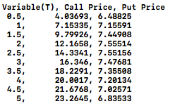 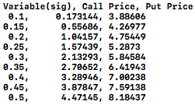

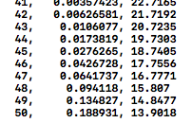

Fig. d Fig. e1 Fig. e2

e) Above are two screenshots of option prices as a function of expiry time (Fig. e1) and volatility (Fig. e2) corresponding to the option parameters of Batch 1.

A.2 (Option Sensitivities, aka the Greeks)

a) Gamma and delta calls results:

Gamma: 0.0134938

Delta for call: 0.59462

Delta for put: -0.356609

b) Fig. b is a screenshot of the delta call as a function of underlying values (S).

 

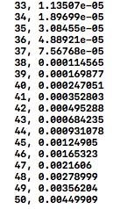 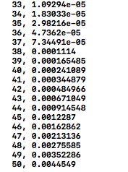

Fig. b Fig. c

c) Using divided differences to approximate option sensitivities

Comparison with the results in a):

|  |  |  |  |
| --- | --- | --- | --- |
|  | Gamma | Delta Call | Delta Put |
| Exact Solution | 0.0134938 | 0.59462 | -0.356609 |
| h = 10 | 0.013421 | 0.589981 | -0.361249 |
| h = 1 | 0.013791 | 0.594039 | -0.357191 |
| h = 0.1 | 0.0137905 | 0.594099 | -0.35713 |
| h = 0.01 | 0.0137905 | 0.5941 | -0.35713 |
| h = 0.001 | 0.0137905 | 0.5941 | -0.35713 |
| h = 0.0001 | 0.0137909 | 0.5941 | -0.35713 |
| h = 0.00001 | 0.0137845 | 0.5941 | -0.35713 |
| h = 0.000001 | 0.00710543 | 0.5941 | -0.35713 |

Theoretically, here the errors in the divided differences approximations are on the order of *O(h2)*. For this particular set of option parameters, a fairly large value of h (e.g., 10) still yields reasonable results. When h is significantly small (e.g. 0.000001), round-off errors emerge.

A screenshot of delta for call as a function of S with the divided differences approximation and h = 0.01 is shown in Fig. c. The delta for call is accurate to four places behind the decimal point.